**SEMESTER TWO 2017**

**YEAR 12, Units 3 & 4**

**MATHEMATICS METHODS**

**Section Two – Booklet 2**

**(Calculator–assumed)**

**Name: _________________________________**

|  |  |  |  |
| --- | --- | --- | --- |
| **MAW** | **VMU** | **MPC** | **AGC** |

**Teacher:**

**TIME ALLOWED FOR THIS SECTION**

Reading time before commencing work: ten minutes

Working time for section: one hundred minutes

**MATERIAL REQUIRED / RECOMMENDED FOR THIS SECTION**

**To be provided by the candidate**

Standard items*:* pens, pencils, pencil sharpener, highlighter, eraser, ruler.

Special items: drawing instruments, templates, notes on up to two unfolded sheet of A4 paper, and up to three calculators approved for use in the ATAR examinations.

**IMPORTANT NOTE TO CANDIDATES**

No other items may be taken into the examination room. It is **your** responsibility to ensure that you do not have any unauthorised material. If you have any unauthorised material with you, hand it to the supervisor **before** reading any further.

**To be provided by the supervisor**

Question/answer booklet for Section Two.

Formula sheet retained from Section One.

**Structure of this examination**

|  |  |  |  |  |  |
| --- | --- | --- | --- | --- | --- |
|  | Number of questions available | Number of questions to be answered | Working time (minutes) | Marks available | Percentage of exam |
| Section One  Calculator—free | 9 | 9 | 50 | 50 | 35 |
| **Section Two**  **Calculator—assumed** | **12** | **12** | **100** | **86** | **65** |
| Total marks | | | | 136 | 100 |

**Instructions to candidates**

1. The rules for the conduct of the Western Australian external examinations are detailed in the *Year 12 Information Handbook 2017.* Sitting this examination implies that you agree to abide by these rules.

2. Write your answers in the Question/Answer booklet.

3. You must be careful to confine your responses to the specific questions asked and to

follow any instructions that are specific to a particular question.

4. Spare pages are provided at the end of this booklet. If you need to use them, indicate

in the original answer space where the answer is continued i.e. give the page number.

5. Show all your working clearly. Your working should be in sufficient detail to allow your answers to be checked readily and for marks to be awarded for reasoning. Incorrect answers given without supporting reasoning cannot be allocated any marks. For any question or part question worth more than two marks, valid working or justification is required to receive full marks. If you repeat an answer to any question, ensure that you cancel the answer you do not wish to have marked.

6. It is recommended that you **do not use pencil**, except in diagrams.

7. The Formula Sheet is **not** to be handed in with your Question/Answer booklet.

**This page has intentionally been left blank.**

**Question 10 (2+3 = 5 marks)**

Gold-198 is a radioactive antineoplastic that is used in the treatment of some cancers. It has a half-life of 2.7 days. This means that every 2.7 days, one half of the gold-198 decays to form an isotope that is no longer radioactive.

This decay can be represented by the equation 

Where = amount of gold-198 present after *t* days, and

= initial amount of gold-198 initially present.

a) Determine the value of correct to three decimal places.

b) A patient is administered a dose of 27 grams of gold-198. During which day after administering the dose, is there less than 2 grams in the patient’s system?

**Question 11 (3+6 = 9 marks)**

A rectangle is inscribed in a semicircle, as shown in the diagram below.

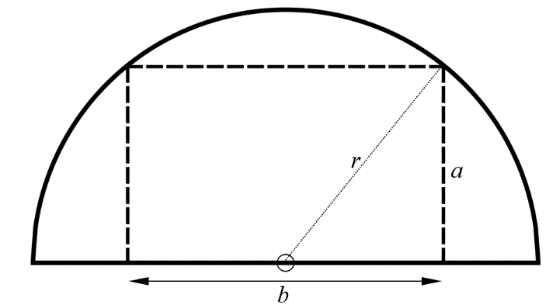

Where:

*r* is the radius of the semicircle,

which is 8cm.

*a* is the height of the inscribed rectangle.

*b*  is the width of the inscribed rectangle

a) Show the area of the inscribed rectangle is given by: 

b) Use calculus methods to calculate the dimensions of the inscribed rectangle of maximum area.

**Question 12 (1+2+2+3+3=11 marks)**

A newspaper delivery vehicle sets out each morning at 5:00am to deliver newspapers to his customers. He has two delivery routes, A and B, he can take to deliver newspapers to his customers. All newspapers should be delivered by 6:00am.

When the delivery vehicle uses route A, the delivery times can be assumed to be normally distributed with a mean of 55 minutes and a standard deviation of 10 minutes.

When the delivery vehicle uses route B, the delivery times can be assumed to be normally distributed with a mean of *μ* minutes and a standard deviation of 12 minutes.

a) For delivery route A, calculate the probability the deliveries take longer than 60 minutes.

b) For delivery route B, the probability the delivery takes less than 60 minutes is 0.7. Determine the value of *μ*.

c) Which delivery route should the driver choose? Provide reasoning.

**Question 12 continued**

d) Given the delivery driver took route A and was late completing the deliveries, calculate the probability deliveries were completed by 6:10am.

e) On five consecutive days the delivery driver takes route B.

Determine the probability:

i) he completes all newspaper deliveries before 6:00am on all five days.

ii) he completes the deliveries before 6:00am on exactly 3 of the 5 days.

**Question 13 (5 marks)**

Sketch the function given the following features.

* 
*  at  and 
*  for  and 
*  at  and 
*  for  and 

Clearly label all key features.

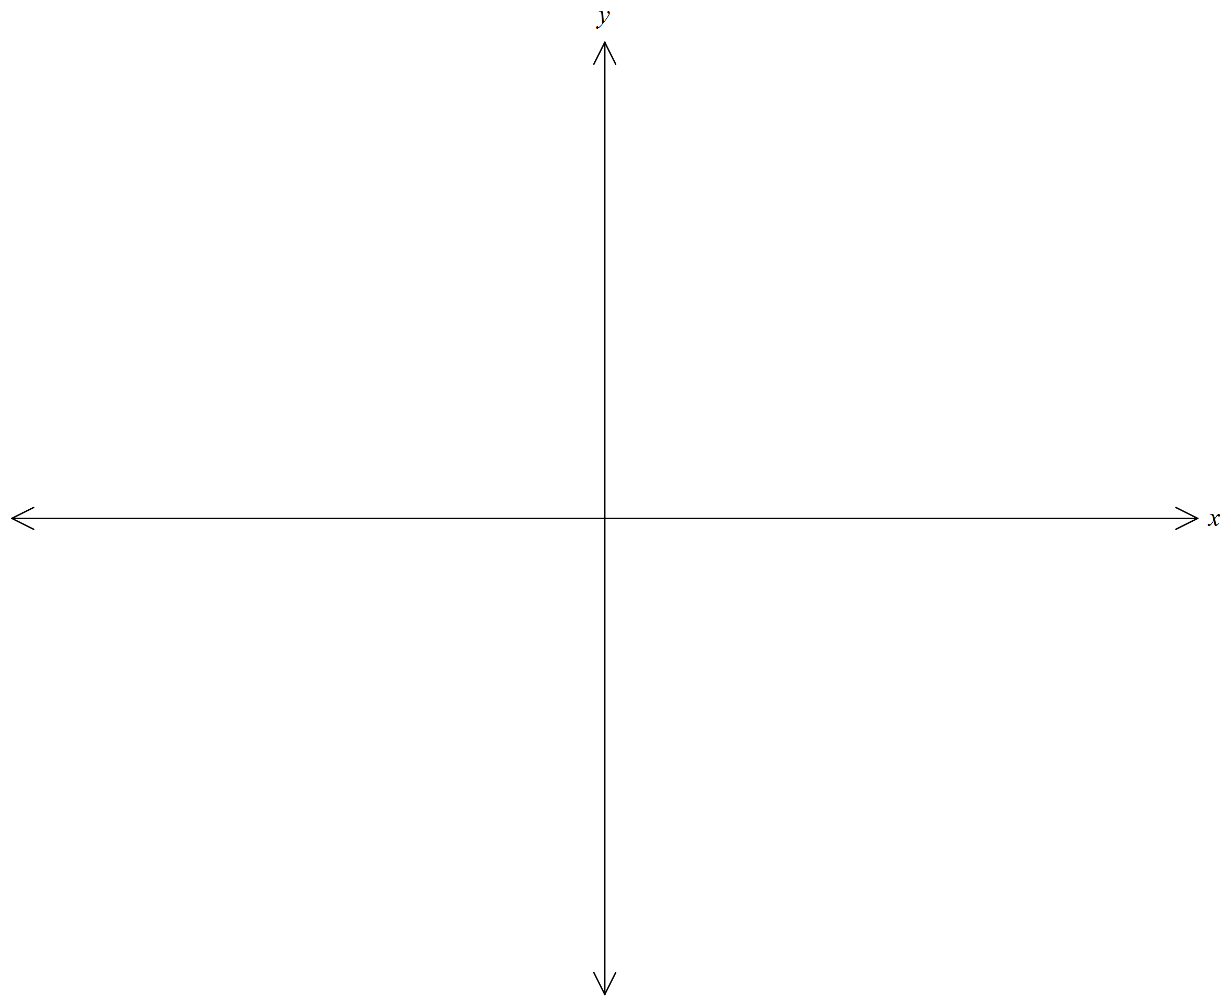

**Question 14 (2+3+2+3 = 10 marks)**

The stylus for the Surface Pro uses a single AAAA battery. These batteries have an operational life which is normally distributed with a mean of 85 hours and standard deviation of 10 hours.

a) Determine the probability that a randomly chosen stylus will fail, due to its battery, before 100 hours of use.

Samples of size *n* , where *n* > 50, stylus batteries are selected and the proportion with a life exceeding 100 hours is recorded.

b) For *n* = 120 describe the sampling distribution of the proportion of stylus batteries with an operational life exceeding 100 hours.

c) For *n* = 120 , calculate the probability that a randomly exceeding chosen sample has a sample proportion of stylus batteries with an operational life exceeding 100 hours of between 0.02 and 0.03.

d) Determine the possible values of *n* if the standard deviation of the sampling distribution,

*n* > 50, of the proportion of stylus batteries with an operational life exceeding 100 hours is not to exceed 0.01.

**End of Questions for Booklet 2**

Spare Working Page

Spare Working Page

Spare Working Page